Reflection & Extra Credit Assignment

The Robert & Mary Neher Global Sustainability Lecture Series brings together voices from science, the arts, and public life to explore how creativity, innovation, and inquiry shape a sustainable future.  This reflection invites you to connect what you learned from one of this year’s speakers with your own academic and personal growth as a lifelong learner. | 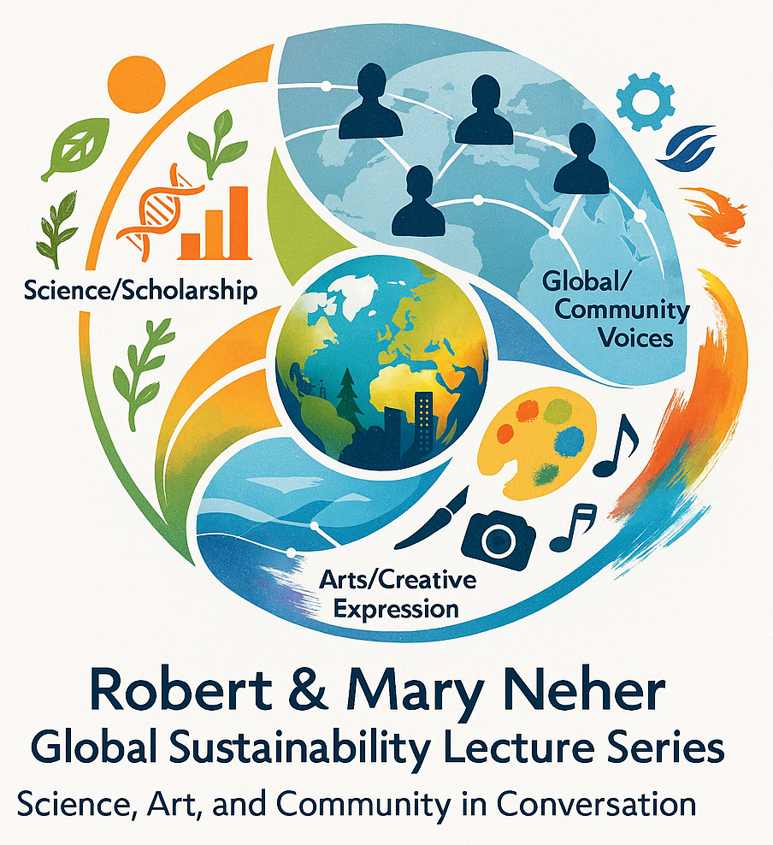

Instructions:
Attend one (or more) of the Neher Lecture events – whether the Global Keynote (virtual), Campus Keynote (on-site), or Art Keynote (gallery exhibition).
Then respond thoughtfully to the following questions in a short paragraph each (2–4 sentences per question).

- First Impressions
- What was your initial reaction to the speaker, presentation, or artwork? Describe one moment, image, or idea that caught your attention and why it stood out.

- Connection to Your Learning
- Did anything you heard or saw connect to something you’ve learned in one of your courses (past or present)? Explain the connection.

- STEAM (Science, Technology, Engineering, Arts, and Mathematics)
- The College of Arts & Sciences embraces a STEAM approach – integrating science, technology, engineering, the arts, and mathematics. How did this event illustrate the power of connecting these areas?

- Global Perspective
- How did the speaker or artist’s work expand your view of global sustainability, climate change, or human creativity in addressing environmental challenges?

- Personal Resonance
- What part of the talk or artwork resonated most with your own experiences, values, or community? Why?
- If it’s an artwork, take a selfie with your favorite piece and include a brief note about why it stood out to you — what drew your attention or made you feel connected?

- Curiosity & Questions
- What kinds of questions were asked during the event, and what did they reveal about how people engaged with the speaker or artist?
If you asked a question yourself, what did you learn from the response or from the experience of participating?
If you didn’t ask a question, what might have held you back – and what could help you feel more confident about engaging next time?

- Learning Beyond the Classroom
- How did this event help you see learning as something that happens outside of classes and grades?
- What surprised you about hearing directly from a professional or creative in the field?
- How has this inspired you to think about your own research or creative explorations?

- Diversity & Representation
- Many of the Neher Lecture speakers bring perspectives shaped by diverse backgrounds and lived experiences. Why do you think it’s important for universities to highlight global and inclusive voices in conversations about sustainability?

- Community Impact
- What ideas or examples from the presentation could apply to your own community or career path?
- How might you take action or share what you learned?
- Does this inspire collaboration or a new way to work with others?

- Lifelong Learning
- How did this event change the way you think about your role as a student, future professional, or citizen of the world?

Submission:
Your responses may be shared with your instructor for extra credit. Aim for 1–2 pages total.
You’re encouraged to write in your authentic voice – this reflection is about curiosity, connection, and growth.

