Operating Systems, by Joe Pan reviewed by Christine Martins
Spork Press, 2019

Joe Pan is the author of five books in an ongoing series of autobiomythographies, which include the poetry collections Operating Systems, Soffritto, and Hiccups. He is publisher and editor-in-chief of Brooklyn Arts Press, an independent publisher honored in 2016 with a National Book Award win in Poetry, as well as the publisher of Augury Books. His work has appeared in The New York Times, The Philadelphia Review of Books, and Boston Review. His latest work, Operating Systems is an ambitious collection that blends genres, combining experimental narratives and lyrics with thought-provoking poetry.
Pan’s maximalist style combines familial, fantastical, and socially political poetry in Operating Systems. This collection includes the “Ode to the MQ-9 Reaper,” a long poem about drone warfare being taught in classrooms throughout the United States. It also approaches complicated stories with empathy and respect. The reader can find loving poems about family members, bitter poems about personal struggles, and rebellious poems about activism and contemporary issues. The collection is also divided into sections, which are “Alluvial Histories,” “Death of Economics,” “The New Arts,” “Internal States of the Garden Thrush,” and “Ode to the MQ-9 Reaper.”
Operating Systems uses an interesting combination of poetic devices and structures that allows the reader to interact with the text. The structure is constantly changing from prose to stanzas, allowing different rhythms and forms to emerge. The author particularly explores different forms, which gives the collection another layer. One poem that demonstrates this is “The Film.” It is a narrative poem that is written in grey and black. The letters highlighted in grey form a poem that can be read by itself. Knowing this, the author writes the prose indicating that the highlights have a deeper meaning than is led on. Then, on a separate section, the author creates a table that contains the transcription of the grey letters, arranged in stanzas. The reader can observe how one poem interacts with the other on Image 1 and 2, at the end of the review. This poem is particularly interesting to read because it allows the reader to interact with the text, searching for the deeper meaning of the highlighted passages and being rewarded with the table containing a new poem in conversation with the previous one. Having the reader feel rewarded and accomplished for seeing what the author is trying to do is a great way of ensuring that the audience enjoys the book. A structure that can be interacted with helps the reader move through the poem and keeps the audience interested. For that reason, we can see how Pan used it, adding another layer of depth to his poems.
Another poetic device that is profoundly explored in this collection is sound. It combined alliteration, assonance, consonance, exact and slant rhyme, and anaphora. The reader can see some of this elements on the first poem of the collection, “Odysseus Teaches One of His New Dogs to Say ‘I Love You.’” The poem, written in prose, is also sideways on the paper, which can be observed on Image 3, at the end of the review.. It starts: “Arrrr! O, arrrg! O, raw scar! How you ore our iron ire, ogre of Troy. Ere your terrors, our eyes were eager ewes, our ears harts yearning for your baked arrows’ rouge! We earned your airy eros, you owned our Aye, sirs. [...] Now we’re an aerie of weary, a renewing well of woe, & worse: auroras of old age. Without war, you whine… O why? O, grrrr! Your errors whorl, rowdy as oars. Argos, return for us! Where are you? O Argos, where? We are you! I of you! I of you” (p. 5). Usually the other poems do not have as much sound work as in this one. Nonetheless, this piece exemplifies how Pan incredible sound work is developed throughout the collection. On the other poems, there is still enough sound and rhythm for the reader to see the author’s intent, but the focus is in depth and imagination, as well as form and tone. The reader can see that through Pan’s brilliant metaphors: “It was always 5 AM with you, always a cold pillow molded in the pillowy shape of loss” (p. 16). Another example can be seen when he is talking about poetry: “Voice like a light left on in an empty bathroom” (p. 47). These metaphors and similes are particularly great due to their uniqueness. Not using idiomatic phrases and still being able to convey feeling and imagery is not easy and Pan does it with excellency. Combined with the simple and sometimes technical diction, these crafts ensured that the reader is moving through the collection in a smooth and interesting way. Overall, Pan did an excellent job exploring different poetic devices. That does not mean that a few poems were not tiring in some way or another. Since several poems were long and in prose form, it is quite easy for the reader to feel distracted and lose focus. For that reason, it could be recommended to read this in paperback and not an e-book.
In conclusion, Operating Systems is a brilliant book that combines lyric and narrative poems with prose and stanza forms about different topics. These topics include familiar events, the different types of art, and socially political issues. One of the highlights of the book is his “Ode to the MQ-9 Reaper,” a long poem that approaches the delicate issue of drone warfare being taught in classrooms. The combination of various themes with the use of different poetic devices makes this book unique and meaningful to a large audience. And the simple diction and the interactive structure makes it significant and accessible to even more people.

Image 1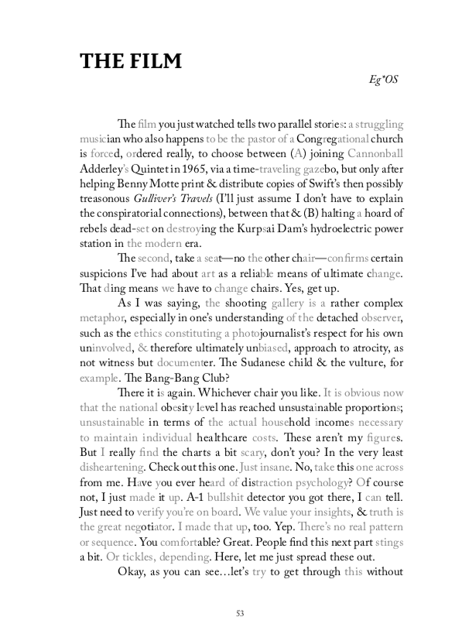
Image 2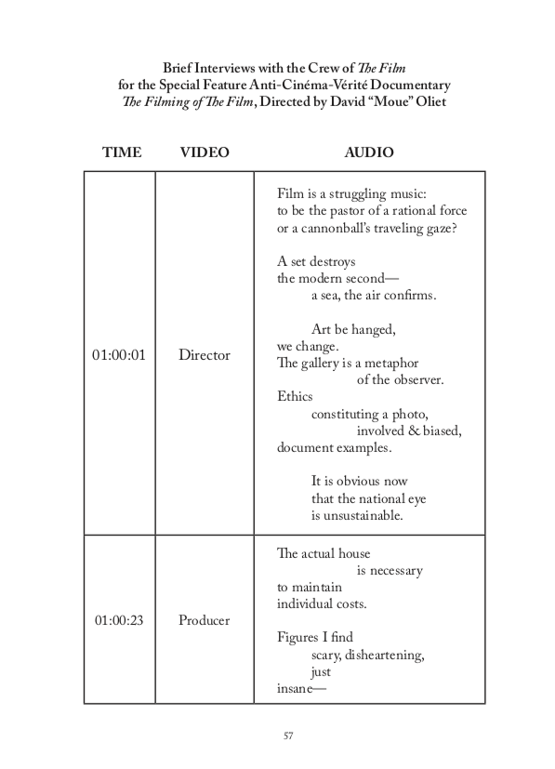Image 3