Alligator and Other Stories, by Dima Alzayat rev. by Sienna Ruiz
Two Dollar Radio

Short, to the point, and captivating is how I would describe Alligator and Other Stories. Dima Alzayat, the author of Alligator and Other Stories, was born in Damascus, Syria, and grew up in San Jose, California, and now lives in Manchester, U.K. Some of her accomplishments include being a winner of a 2018 Northern Writers’ Award, the 2017 Bristol Short Story Prize, and the 2015 Bernice Slote Award. Alligator and Other Stories has received starred reviews from places such as Publishers Weekly and GQ Magazine. The book of emotion-evoking short stories was recently released to the public on May 29, 2020.
Alligator and Other Stories contains nine stories that address many issues within society, and it does so through riveting language, imagery, point of view, and form. Alzayat makes her stories different by experimenting with form. In one story, she inputs poems in between the blocky paragraphs, and not only does this add another interactive element, but it also gives more insight and another interpretation into how the narrator felt while preparing her brother’s body to be buried:

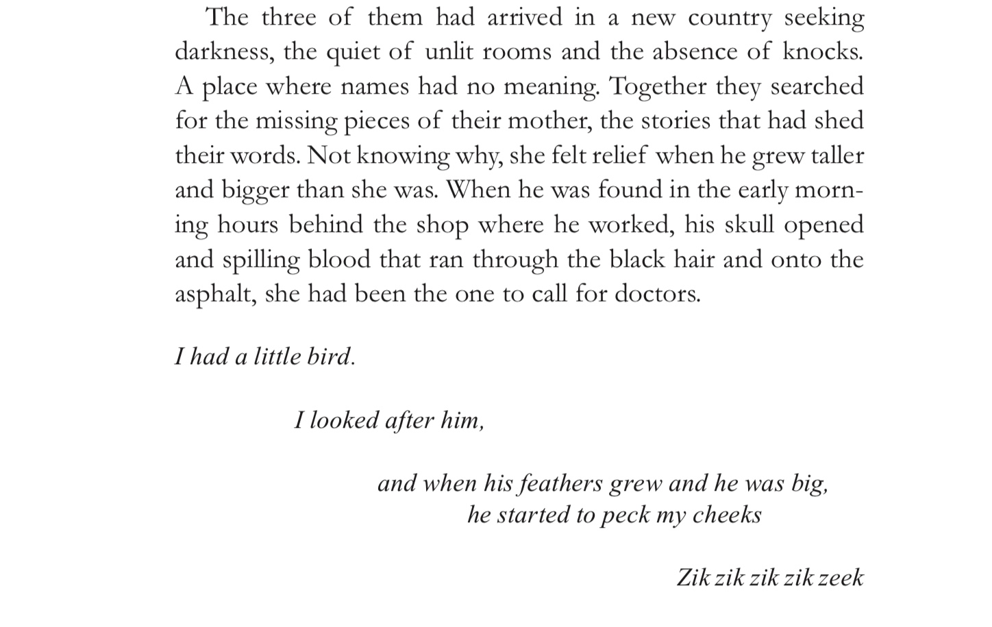

Another way she experiments with form is in “Daughters of Manāt,” through changing the position of the paragraphs when the speaker of the story changes. This not only helps the reader differentiate which woman is speaking, but it also helps transition the story when it’s changing to a different period in time. The woman who is speaking in the present is aligned to the left of the page, while the woman speaking on the traumas throughout different periods in her life is aligned to the right. Each woman speaks on the struggles that all women have to endure due to gender inequality and societal norms. This helps the story feel cohesive, but the way the formatting makes the story even more powerful since two different women are experiencing the same neglect.
Alzayat’s stories show point of views from many different characters, from men, women, and children, and individuals from different backgrounds economically and ethnically. Even though the characters are so diverse, each character’s personality still comes alive on the pages. This is something that can be extremely hard for a writer to do, but Alzayat seems to have mastered it. These characters all also experience different types of trauma whether that be the oppression of women, the loss of innocence through experiencing the loss of a loved one, or abduction and even murder due to gain or racism. Alzayat does a good job of making her characters feel like real people.
In the story “Alligator,” it feels as though you’re reading from the diaries of each person that is mentioned. This story, the longest in the book but one that reads quickly, holds great relevance to what is currently happening within our country. Alzayat took real newspaper clippings and dialogue from interviews and videos from the past to create a story from the point of view of the oppressed. “Alligator” acknowledges groups including Syrians, black Americans, and Native Americans, and she discusses how all these groups have faced and still do face brutality. “Alligator” shows the graveness of just how long the United States has been racist, and it shows how the perspective of oppressing minorities isn’t a learned trait but something our country was built upon:
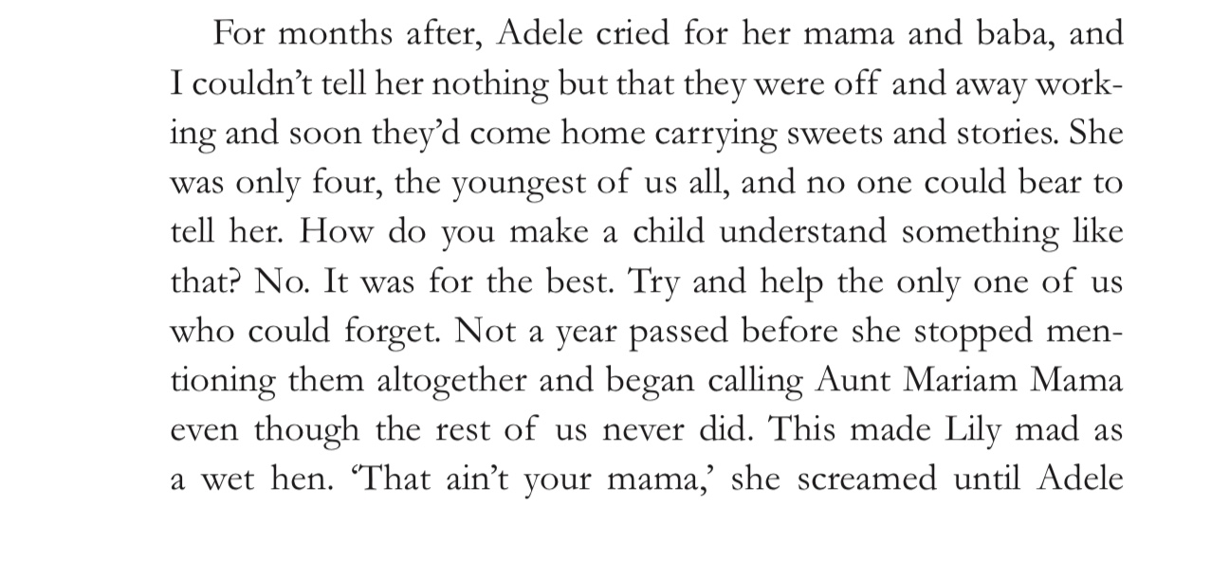
Alligator and Other Stories discuss the social issues that occur not only within our society but in other countries, as well. The stories all address topics that are still problems, such as how women are treated in different cultures. I recommend Alligator and Other Stories to anyone; books like it are the reason it is important to read literature. By addressing issues socially in other cultures, such books help readers step into the shoes of someone they don’t resemble, allowing readers to experience the sufferings of others. Literature like Alligator and Other Stories teaches us empathy. I know that while reading Alzayat’s stories, I felt more human because the book gave me insight into issues I had heard little of before or had not known about at all, and best of all, it made me feel something.

